*Characterization Graphs*

The following plots were used to characterize the linear potentiometer and servo-valve. Data obtained from calibrating the systems was plotted to indicate their gain and offset. These values were inputted into our Simulink models to better match the behavior of the hydraulic positioning system.

Figure 1. Characterization graph for linear potentiometer.

Figure 2. Characterization graph for servo-valve.

*Combination Graphs for Step Input*

The following plots compare the response of the physical system in the experiment and the response of the corresponding Simulink model. These are responses to a repeating sequence step input using different types of controllers with different values. Dotted lines symbolize experimental data and solid lines symbolize model data. Controller type and gains are indicated in the plot titles.

**

Figure 3. Step response of system with P controller.



Figure 4. Step response of system with P controller.



Figure 5. Step response of system with P controller.



Figure 6. Step response of system with P controller.



Figure 7. Step response of system with PD controller.



Figure 8. Step response of system with PID controller.

*Combination Graphs for Ramp Input*

The following plots compare the response of the physical system in the experiment and the response of the corresponding Simulink model. These are responses to a repeating sequence ramp input using different types of controllers with different values. Dotted lines symbolize experimental data and solid lines symbolize model data. Controller type and gains are indicated in the plot titles.



Figure 9. Ramp response for system with P controller.



Figure 10. Ramp response for system with PI controller.

*System in Simulink*

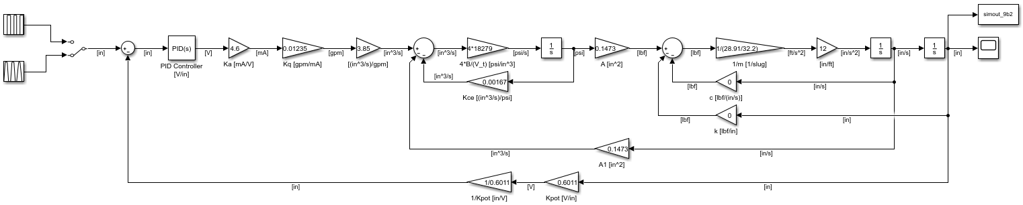Shown below is our Simulink model used to simulate the experiment. A switch was used to go between a repeating sequence step or ramp input. Values and units are displayed for all parameters.

*Derivation of Linear Transfer Function*

The linear transfer function was derived from the proportionally controlled open-loop system. It is shown below in both symbolic and numeric form.

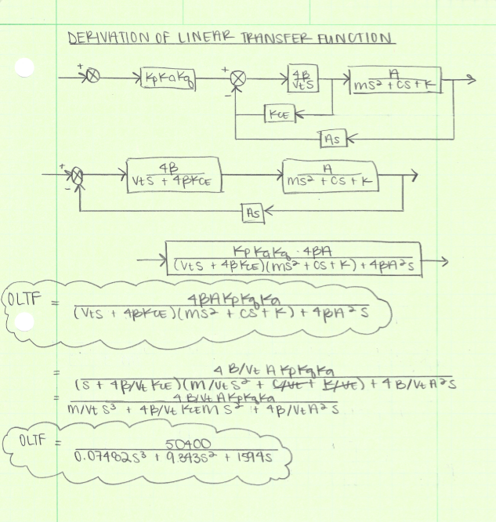

*Analysis for Kce and β/Vt*

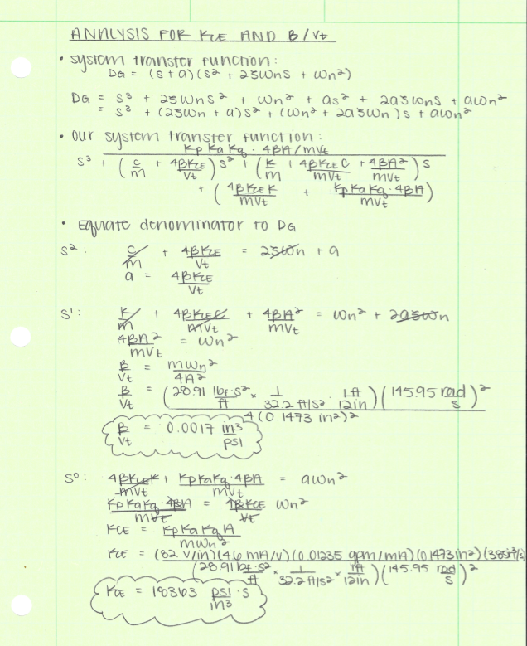An analysis was performed to calculate the parameters Kce and β/Vt using the closed loop transfer function. By comparing this to the system transfer function DG = (s + a)(s2 + 2ζωns + 2ωn2) and equating coefficients the values were able to be calculated.

*Root Locus for Open Loop with Closed Loop Poles*

The root locus is sketched for the system, beginning at the open loop poles. The closed loop poles are also shown for the four P-only controller tests from Step 4. These are symbolized by the red X at a value of -2.14 as well as the open loop pole at 0. The open loop poles, symbolized by the blue X’s, are located at a value of -62.4 ± 132i. Because the value of 62.4 is more than five times the distance from the imaginary axis, a second-order approximation is appropriate for systems utilizing a P-only controller.

